**Maven Installation on Ubuntu**

**1. Install Maven**

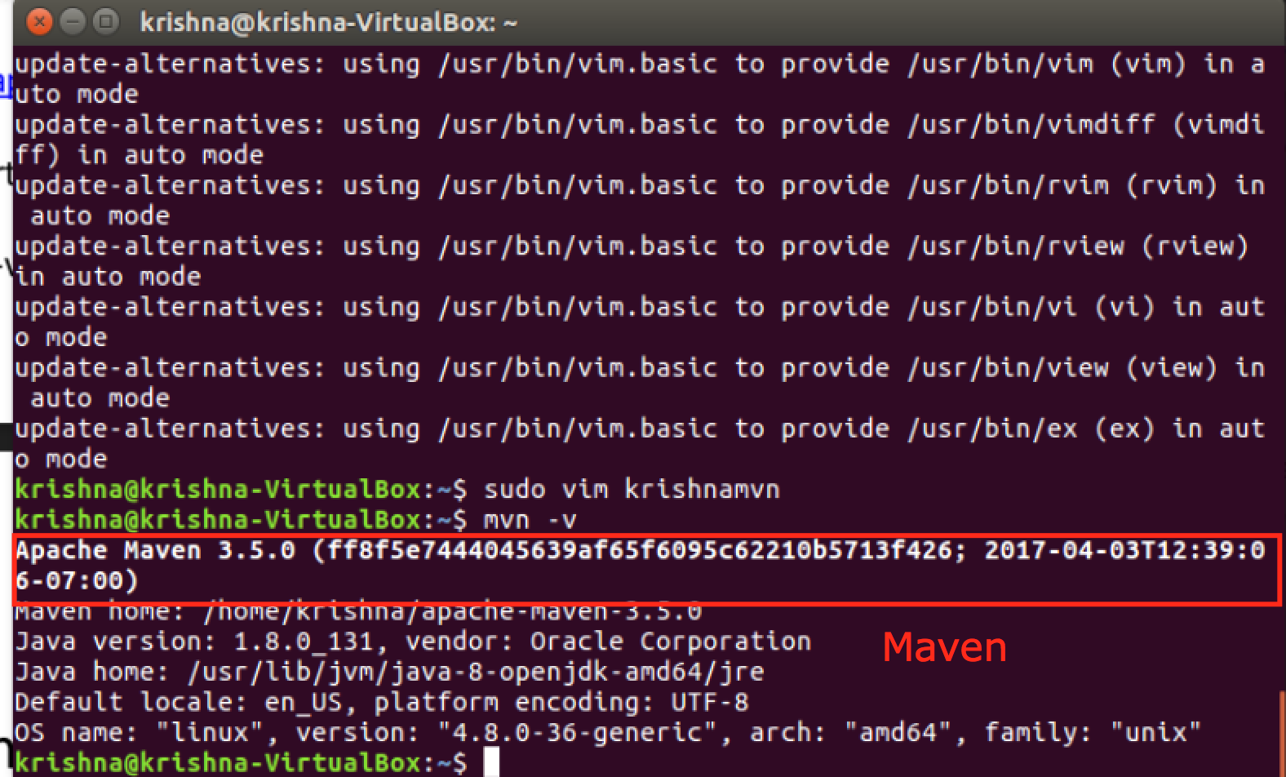

**2. Maven Build**

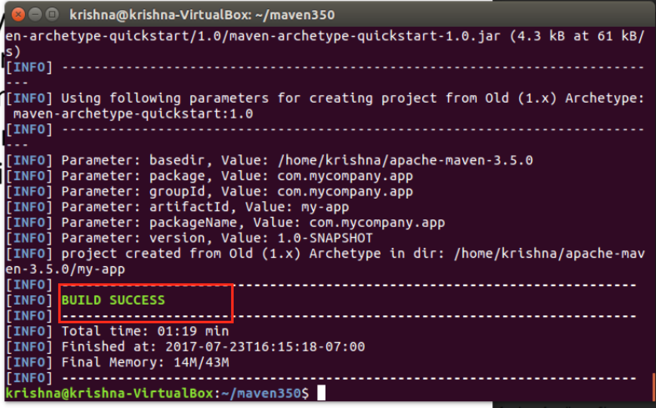

**3. Maven build my-app**

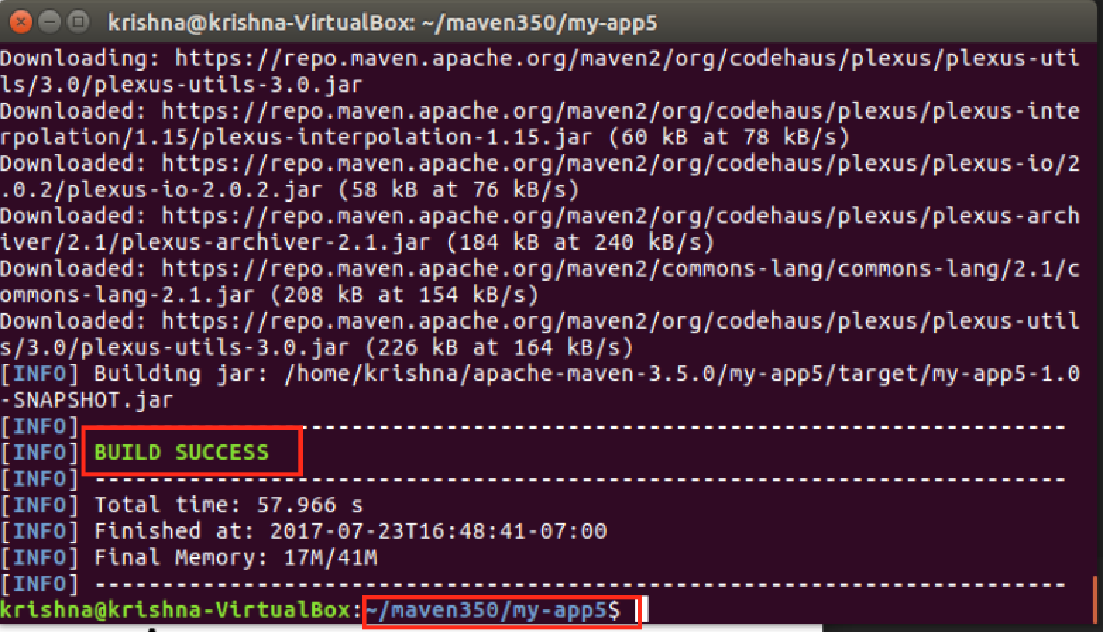

**4. Maven running Hello World**

